

**Homework # 7**

**01286121 Computer Programming**

**Software Engineering Program,**

**Department of Computer Engineering,**

**School of Engineering, KMITL**

By

65011693 Soe Moe Htet

No1

class Clock:

    def __init__(self, hour, minute, second):

        self.hour = hour

        self.minute = minute

        self.second = second

    def set_hour(self, hour):

        self.hour = hour

    def set_minute(self, minute):

        self.minute = minute

    def set_seconds(self, second):

        self.second = second

    def set_time(self, hour, minute, second):

        self.set_hour(hour)

        self.set_minute(minute)

        self.set_seconds(second)

    def tick(self):

        self._second += 1

        if (self._second == 60):

            self._second = 0

            self._minute += 1

            if (self._minute == 60):

                self._minute = 0

                self._hour += 1

                if (self._hour == 24):

                    self._hour = 0

    def get_time(self):

        if(self.hour > 0 and self.hour <= 12):

            state = "AM"

        elif(self.hour > 12 and self.hour < 24):

            self.hour -= 12

            state = "PM"

        elif(self.hour == 12):

            self.hour = 0

            state = "PM"

        elif(self.hour == 24):

            self.hour = 0

            state = "AM"

        print(f"{self.hour:02d}:{self.minute:02d}:{self.second:02d} {state}")

def main():

    clock = Clock(12, 50, 12)

    clock.set_time(9,30,24)

    clock.set_hour(13)

    clock.set_seconds(30)

    clock.get_time()

main()

Sample output:

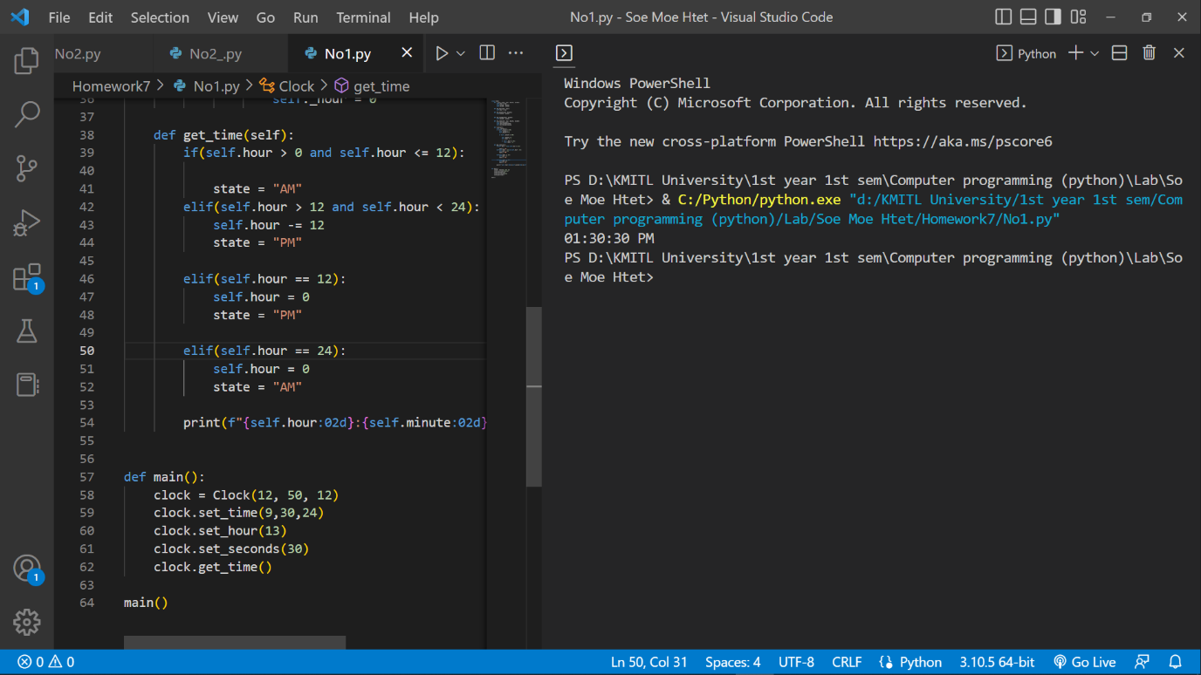

No.2

class Poly:

    def __init__(self, x):

        self.x = list(x)

    def who_is_bigger(self, p):

        first_power = self.find_powerOfx()

        first_coef = self.x

        second_power = p.find_powerOfx()

        second_coef = p.x

        if (len(first_power) >= len(second_power)):

            bigger_coef = first_coef

            bigger_power = first_power

            smaller_coef = second_coef

            smaller_power = second_power

        elif (len(first_power) < len(second_power)):

            bigger_coef = second_coef

            bigger_power = second_power

            smaller_coef = first_coef

            smaller_power = first_power

        while(len(smaller_power) != len(bigger_power)):

            smaller_power += (0,)

            smaller_coef += (0,)

        return (smaller_coef, smaller_power, bigger_coef, bigger_power)

    def add(self, p):

        (smaller_coef, smaller_power, bigger_coef, bigger_power) = self.who_is_bigger(p)

        new_coef = []

        for i in range(0, len(bigger_power)):

            if bigger_power[i] == smaller_power[i]:

                new_coef += (smaller_coef[i] + bigger_coef[i],)

            else:

                new_coef += (bigger_coef[i],)

        self.x = new_coef

        return Poly(self.x)

    def scalar_mulltiply(self, n):

        for i in range(len(self.x)):

            self.x[i] *= n

        return Poly(self.x)

    def multiply(self, p):

        #(smaller_coef, smaller_power, bigger_coef, bigger_power) = self.who_is_bigger(p)

        new_coef = []

        # print(len(self.x) + len(p.x) - 1)

        for i in range(0, (len(self.x) + len(p.x)) -1 ):

            new_coef += (0, )

        # [0 + 0] += 1*1

        # [0 + 1] += 1*1

        # [1 + 0] += 1*1

        # [1 + 1] += 1*1

        # [2 + 0] += 1*1

        # [2 + 1] += 1*1

        # print(f"new_coef = {new_coef}")

        i = 0

        while(i != len(self.x)):

            j = 0

            while(j != len(p.x)):

                new_coef[i+j] += (self.x[i] * p.x[j])

                j += 1

            i += 1

        # print(f"new_coef = {new_coef}")

        return Poly(new_coef)

    def power(self, n):

        new_coef = []

        # print(len(self.x) + len(self.x))

        for i in range(0, (len(self.x) *n ) -1 ):

            new_coef += (0, )

        # [0 + 0] += 1*1

        # [0 + 1] += 1*1

        # [1 + 0] += 1*1

        # [1 + 1] += 1*1

        # [2 + 0] += 1*1

        # [2 + 1] += 1*1

        # print(f"new_coef = {new_coef}")

        i = 0

        while(i != len(self.x)):

            j = 0

            while(j != len(self.x)):

                new_coef[i+j] += (self.x[i] * self.x[j])

                j += 1

            i += 1

        # print(f"new_coef = {new_coef}")

        return Poly(new_coef)

    def find_powerOfx(self):

        count = 0

        powers = ()

        for i in self.x:

            if (i == 0):

                powers += (0,)

                count += 1

                continue

            else:

                powers += (count,)

                count += 1

        return powers

    def diff(self):

        new_coef = ()

        for i in range(len(self.x)-1):

            new_coef += (self.x[i + 1] * (i + 1),)

        return Poly(new_coef)

    def integrate(self):

        # ∫ x^n dx = (( x^(n+1) ) / (n+1))+C ; n≠1

        new_coef = []

        # print(f"len(self.x) = {len(self.x)}")

        for i in range(0, len(self.x)+1):

            new_coef += (0, )

        # print(f"new_coef = {new_coef}")

        original_powers = self.find_powerOfx()

        print()

        for i in range(0, len(self.x)):

            # print(f"self.x[i] / original_powers[i] + 1  = {self.x[i] // original_powers[i] + 1 }")

            new_coef[i+1] = (self.x[i] / (original_powers[i] + 1 ))

            # print(f"self.x[i] : {self.x[i]}")

            # print(f"original_powers[i] : {original_powers[i] + 1}")

            # print()

        # print(f"new_coef = {new_coef}")

        return Poly(new_coef)

    def print(self):

        count = 0

        for i in self.x:

            sign = "+"

            if i < 0:

                sign = "-"

            if ( count == 0):

                sign = ""

            if (i == 0):

                count += 1

                continue

            else:

                i = abs(i)

                if count == 0:

                    print(f"{sign}{int(i)} ", end = "")

                else:

                    print(f"{sign} {int(i)}x^{count} ", end = " ")

                count += 1

        print()

    def eval(self, n):

        count = 0

        total = 0

        for i in self.x:

            if (i == 0):

                # print(f"Skipped {count}^th power since it's coeff is 0.")

                count += 1

                continue

            else:

                # print(f"total = {total}")

                total += i * (n ** count)

                # print(f"{i} * ({n} ** {count}) = {total}")

                count += 1

        print(total)

def main():

    #          0th, 1th, 2th, 3th, 4th, ....

    p = Poly( (  1, 2, 3) )

    p.print()

    print()

    p.diff().print()

    p.integrate().print()

    # q = p.power(2)

    # q.print()

    # p.print()

    # p.eval(3)

    # print(p.find_powerOfx())

    # print(q.find_powerOfx())

    # r = p.add(q)

    # r.print()

    # p.scalar_mulltiply(2)

    # p.print()

    # s = Poly((1,1))

    # s.print()

    # r = p.multiply(s)

    # r.print()

    # p.diff()

    # print(f"Diff of p : ", end = "")

    # p.print()

    # r = p.power(2)

    # r.print()

main()

Sample output

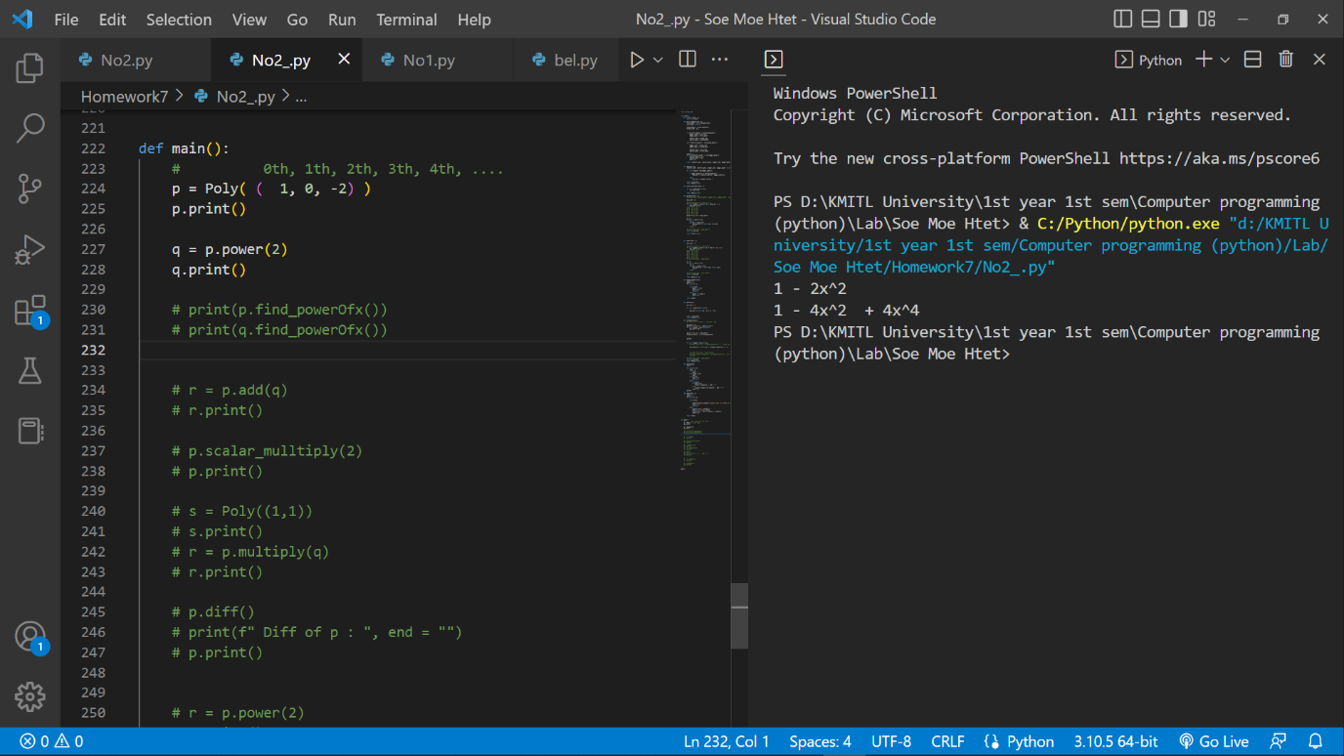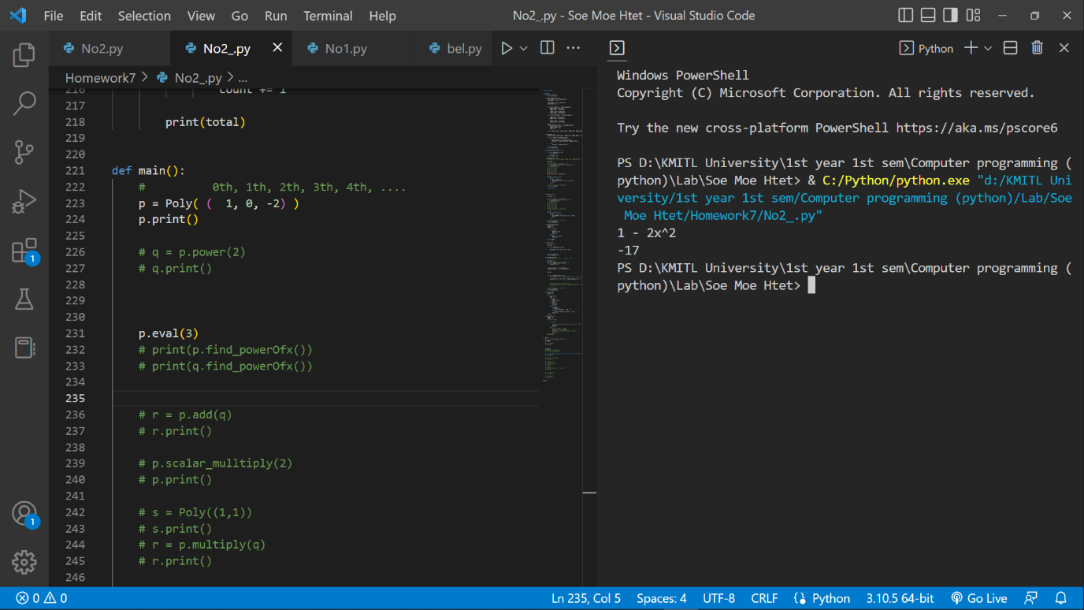

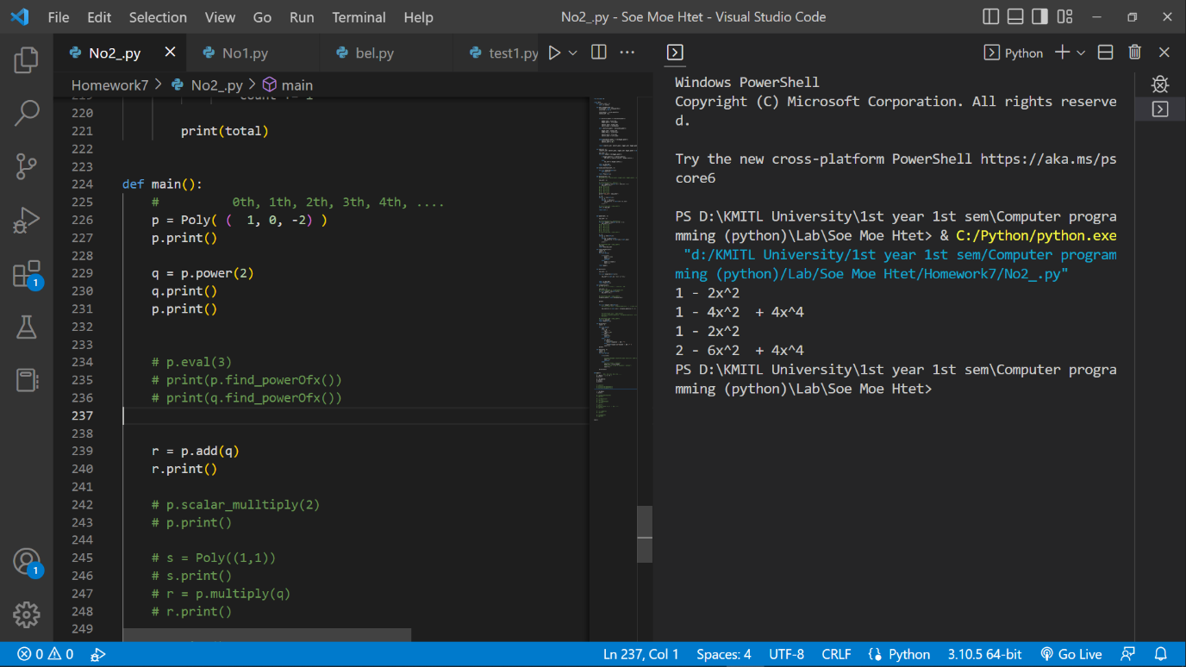

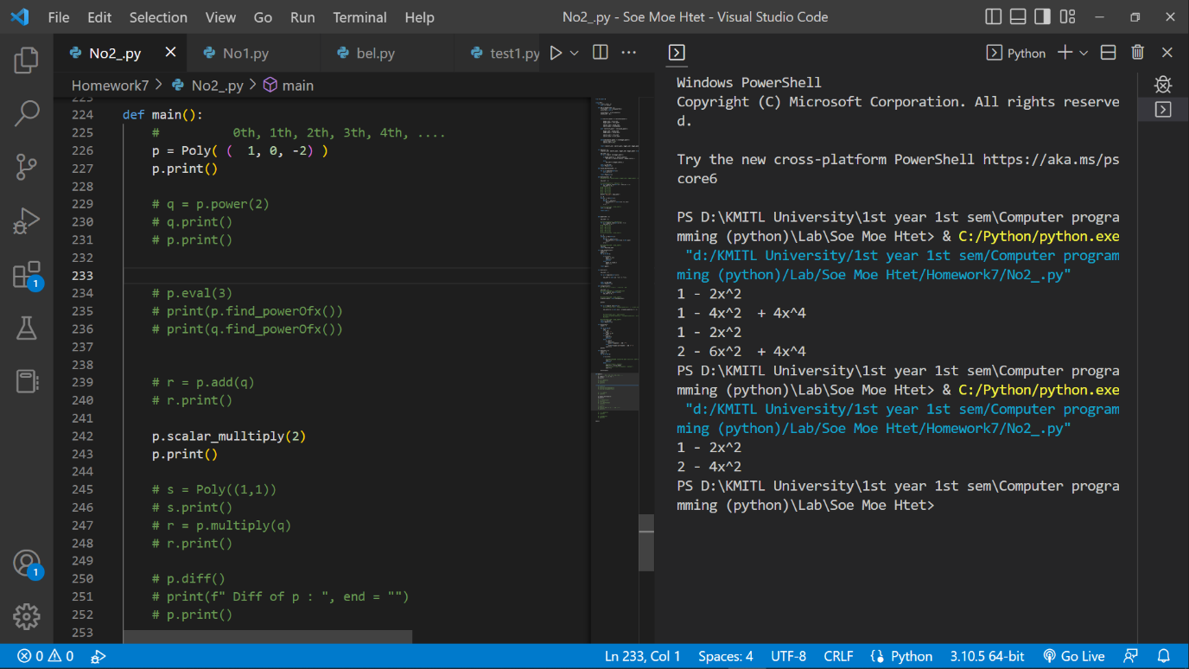

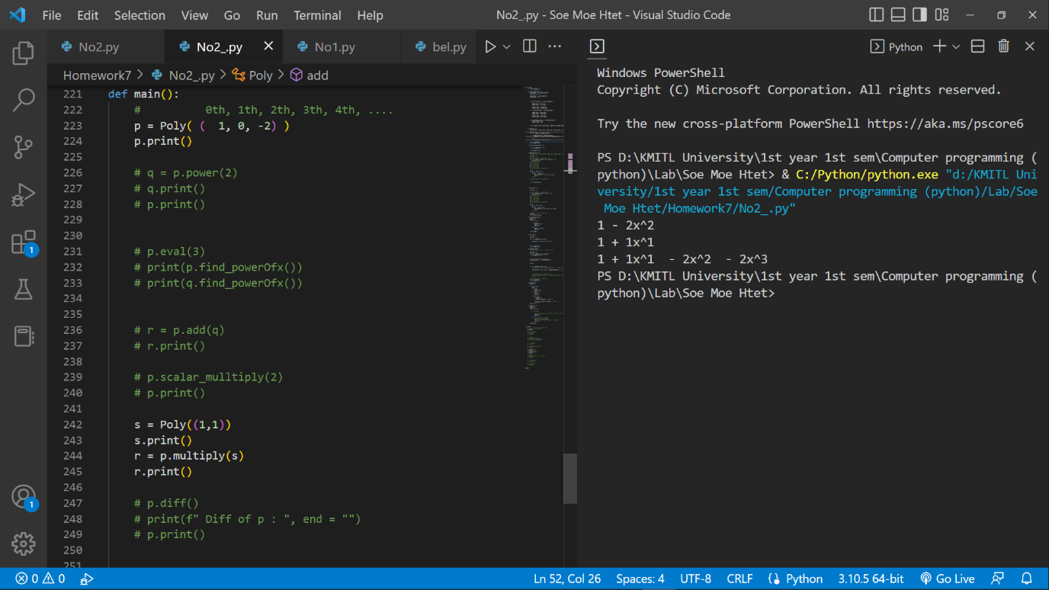

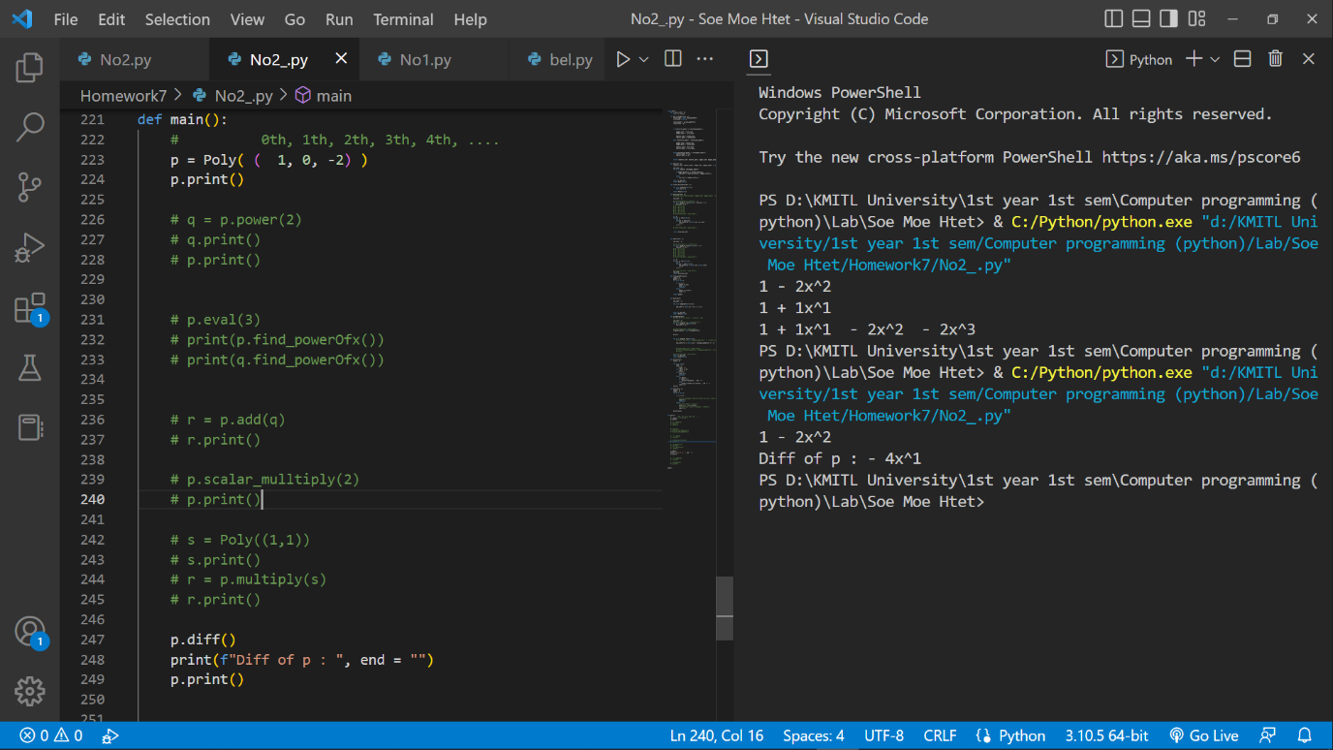

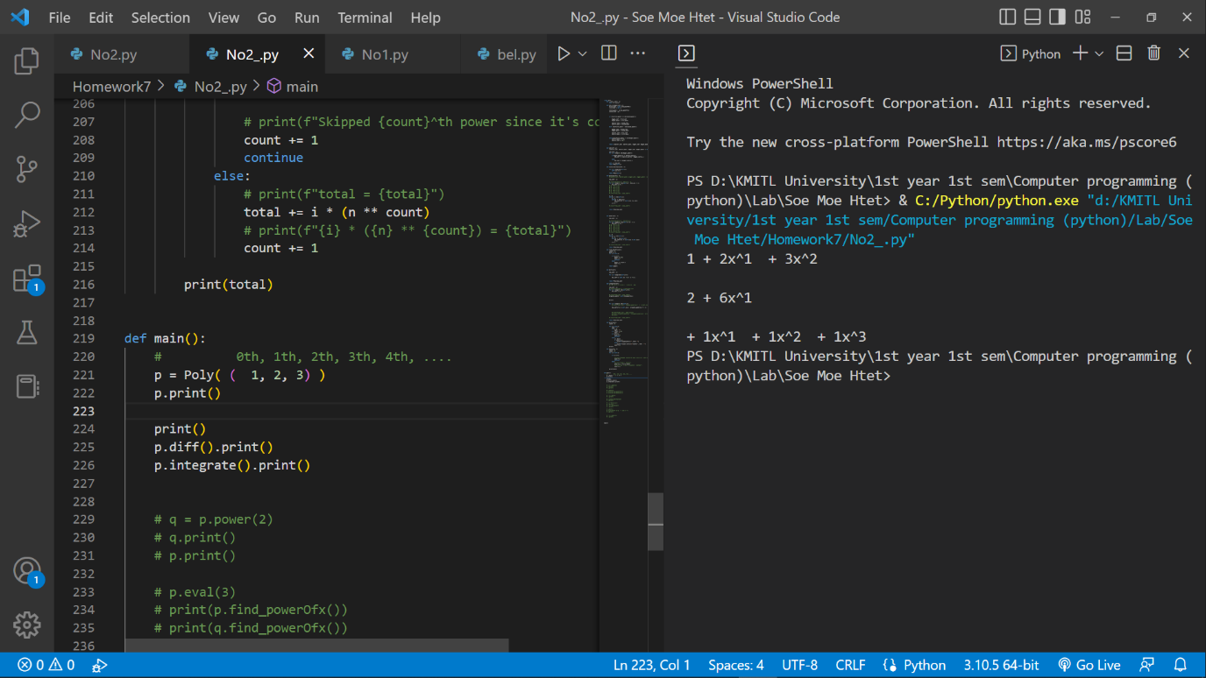

No3

class LinearEquation:

    def __init__(self, a, b, c, d, e, f):

        self.__a = a

        self.__b = b

        self.__c = c

        self.__d = d

        self.__e = e

        self.__f = f

    def get_a(self, a):

        return self.__a

    def get_b(self, b):

        return self.__b

    def get_c(self, c):

        return self.__c

    def get_d(self, d):

        return self.__d

    def get_e(self, e):

        return self.__e

    def get_f(self, f):

        return self.__f

    def isSolvable(self):

        if( (self.__a * self.__d) - (self.__b* self.__c) !=0 ):

            return True

        else:

            return False

    def getX(self):

        top =( self.__e * self.__d) - (self.__b * self.__f)

        bottom = (self.__a * self.__d) - (self.__b * self.__c)

        return top / bottom

    def getY(self):

        top =( self.__a * self.__f) - (self.__e * self.__c)

        bottom = (self.__ * self.__d) - (self.__b * self.__c)

        return top / bottom